Michael Parmelee/NBC

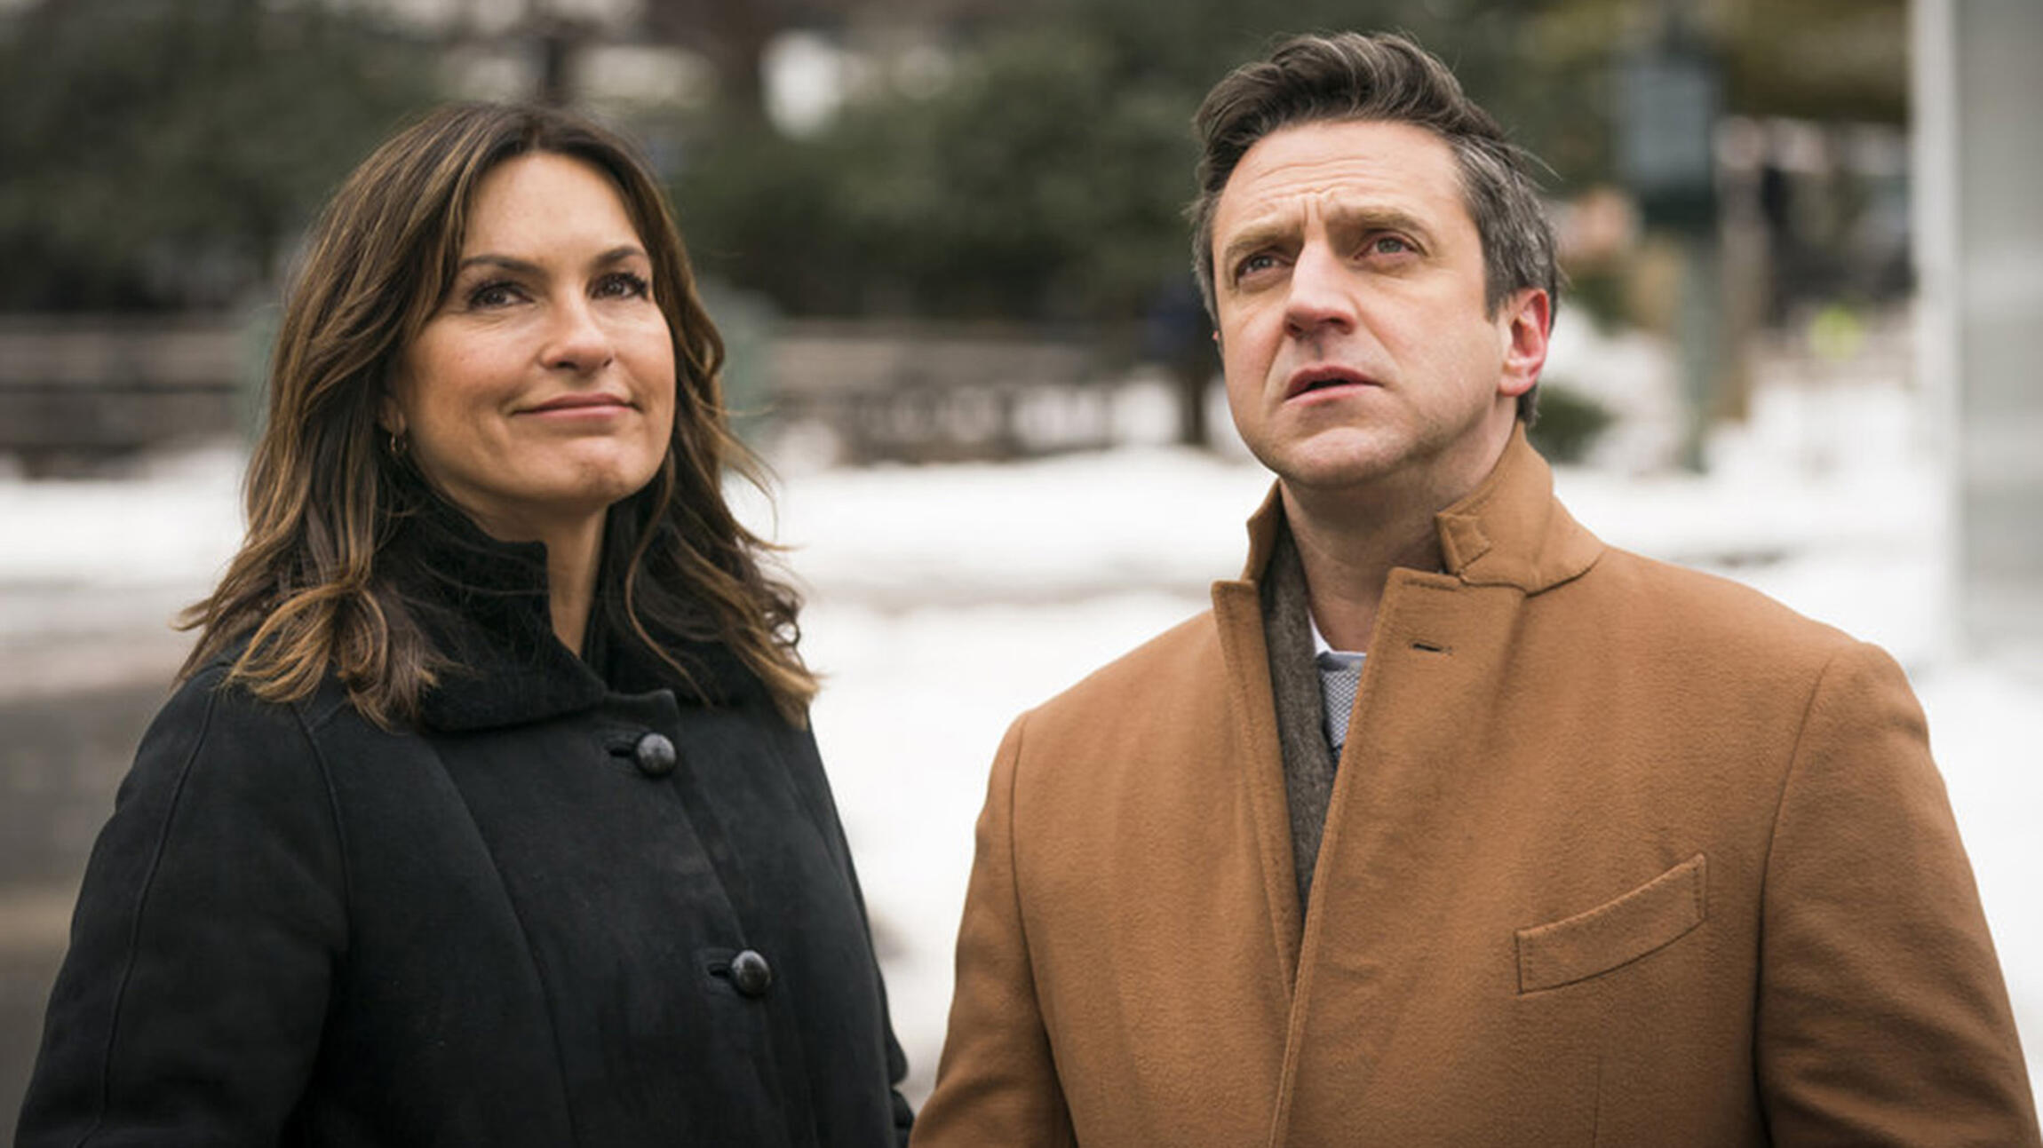

# [**Olivia Benson's Best Partner on Law & Order: SVU Was Actually ADA Barba**](https://www.tvguide.com/news/features/law-order-svu-olivia-benson-rafael-barba/)

Benson and Barba naturally balanced each other, which is why nothing — and no one — can hold a candle to their friendship

[**Krutika Mallikarjuna**](https://www.tvguide.com/authors/krutika.mallikarjuna/)

July 17, 2020

When Rafael Barba ([Raul Esparza](https://www.tvguide.com/celebrities/raul-esparza/credits/264613/)) first met Olivia Benson ([Mariska Hargitay](https://www.tvguide.com/celebrities/mariska-hargitay/164490/)) in Season 14 of [*Law & Order: SVU*](https://www.tvguide.com/tvshows/law-order-special-victims-unit/100257/), he asked her interim captain whether it was Take Your Daughter To Work Day. Benson, a Special Victims Unit detective with nearly two decades of experience, nodded a polite hello to the new assistant district attorney with a look in her eye that promised she wouldn't forget that snide little comment. In the early post-Stabler ([Chris Meloni](https://www.tvguide.com/celebrities/christopher-meloni/144798/)) era of the series — during which the show struggled to find the right balance of personalities and frequently cycled through new characters — Barba's introduction seemed poised to tip the carefully balanced energy that always existed between the law and the order into chaos. But despite their rocky start, Barba became Benson's most compelling partner out of *SVU*'s entire 21-season run.

Barba's slick, arrogant, morally questionable methods on his first special victims case in "Twenty Five Acts" — which included bullying a rape survivor into testifying by threatening her with perjury charges, railroading her college professor into blowing up her professional career, and grandstanding in front of the press — won him no respect from *SVU'*s most compassionate detective. But just as Benson was ready to write him off as the kind of lawyer who cared more about his professional record than getting justice, Barba took off his belt, looped it around his own neck, and asked the defendant in the jury box to take the other end and demonstrate how he choked his victim. In a courtroom scene unlike any other on *SVU*, Barba's stunt revealed the man's true violent nature to the jury, who had been on the brink of acquitting him of rape. Despite the blunt and cutting way Barba had dealt with the survivor in order to make the case airtight, when pushed, he went above and beyond in the courtroom to get the conviction — and that dedication was something Benson understood and could respect.

[TV Throwback: The Best Shows to Rewatch Right Now](https://www.tvguide.com/news/tv-throwback-best-shows-to-rewatch/)

After finding that common ground, their friction settled into a steady simmer. When Barba's childhood friend got caught up in a sexting and bribery scandal during a mayoral run, Barba turned to Benson to ensure that he didn't cross any professional lines while the investigation was ongoing. When Benson's frustration over judicial loopholes clouded her testimony in a cold case involving child molestation and murder, it was Barba who reminded her of the victim's mother and why she needed to keep her cool on the stand. When Benson learned who the biological father of her adopted son Noah was and discovered he was a criminal, it was Barba who walked her through the legal hypotheticals and reassured her that Noah's father couldn't challenge the adoption. Each case worked together over five seasons, whether won or lost, brought the pair closer.

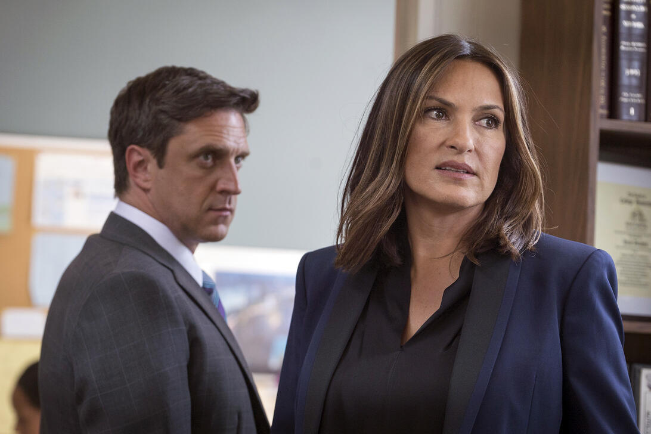

Michael Parmelee/NBC

Benson and Barba naturally balanced each other. Benson cracked cases with empathy and ass-kicking, while Barba caught convictions with political maneuvering and diligent foresight. But the powerful chemistry between the two didn't just spring from the fact that they made up for one another's blind spots; more importantly, the duo learned from each other and pushed each other to grow. By the time Barba left the series in Season 19, he felt so much kinship with a mother fighting for her braindead infant's right to die that he risked incarceration to help her. Thanks to his years with Benson, he knew that empathy could be a source of strength instead of a weakness to exploit. And as for Benson, her time with Barba pushed her to achieve a rigor in her casework that bolstered her eventual promotion to captain of the SVU. With Barba, Benson evolved beyond the heart of the series into the brain as well.

[The Best 2010s Shows to Watch Right Now](https://www.tvguide.com/news/best-2010s-shows-watch-right-now/)

None of Benson's previous partners, squad mates, or friends come close to having had such a positive impact on her as Barba did. No one else could really go toe-to-toe with her as equals. All due respect to the intensity of the early Stabler-Benson years, but there's no version of the show where Liv would be captain of SVU if Stabler had stayed her partner. She would have been stuck prioritizing Stabler's issues and reining in his mercurial tempers, rather than focusing on building her own skill set. Nick Amaro ([Danny Pino](https://www.tvguide.com/celebrities/danny-pino/189756/)) was a younger, sexier version of Stabler, just another partner she had to babysit too often. As for Mike Dodds ([Andy Karl](https://www.tvguide.com/news/law-order-svu-andy-karl-sergeant/)), we hardly knew ye before you were gone. Amanda Rollins ([Kelli Giddish](https://www.tvguide.com/celebrities/kelli-giddish/283343/)), Sonny Carisi ([Peter Scanavino](https://www.tvguide.com/celebrities/peter-scanavino/263359/)), and Kat Tamin ([Jaime Gray Hyder](https://www.tvguide.com/news/well-be-seeing-a-lot-more-of-jamie-gray-hyders-det-kat-azar-tamin-on-law-order-svu/)) are three great additions to the series who love Benson, but honed their skills under her tutelage. John Munch ([Richard Belzer](https://www.tvguide.com/celebrities/richard-belzer/171431/)) and Donald Cragen ([Dann Florek](https://www.tvguide.com/celebrities/dann-florek/189753/)) are beloved mentors to be valued, but also people who've largely left her behind since they retired. Fin Tutuola ([Ice T](https://www.tvguide.com/celebrities/ice-t/154286/)) comes closest to being Benson's equal, a non-judgmental sounding board for her to talk to, but is on a completely different wavelength when it comes to the job. As for the other ADAs? Alex Cabot ([Stephanie March](https://www.tvguide.com/celebrities/stephanie-march/217622/)) grew exceptionally close to Benson over the years but the pair never challenged each other as much as Benson and Barba did. The other ADAs always remained at least a phone call away except for Barba, who snuck straight into her heart.

In Barba's final episode, he stood just outside the courthouse with Benson saying a silent goodbye to the life he once had after escaping a murder charge and losing his job. Barba explained that before he met Benson, he only saw justice in black and white. But after Benson, there was color and now that's all he can see. "I'm you now, Liv. You've opened my heart and I thank you for it," Barba told her. "But I've got to move on." Benson couldn't answer, tears overwhelming her in the moment, but just like that first fateful day, the look in her eye said she'd wouldn't forget it later. This time, after five and half years of deeply enriching partnership, Barba knew her well enough to understand.